Lab 9 — Profiling in Python
Performance profiling, memory profiling, test coverage, and optimization
Student: Mira Khalil | Course: EECE 435L | Fall 2026–2027

1. Objective and methodology
This exercise profiles a Python program with three functions: slow_function (2-second sleep plus 10,000 squared-value additions), fast_function (100 squared-value additions), and memory_intensive_function (10,000,000 squared-value additions). cProfile measures function-level time, line_profiler identifies expensive lines, memory_profiler reports line-level memory use, and coverage.py measures executed statements. Three unittest tests check results and report timing and memory observations.
Optimization applied: replace the explicit 100-iteration accumulation in fast_function with optimized_fast_function, using sum(i ** 2 for i in range(100)). The slow and memory-intensive functions were left unchanged to isolate this requested modification. Results below are from separate runs; system noise and profiler overhead can affect timing.

2. Results summary
Metric | Original | Optimized
cProfile total runtime | 4.438 s | 4.841 s
cProfile memory-intensive self time | 2.434 s | 2.837 s
line_profiler fast function | 0.0002158 s | 0.0001216 s
line_profiler slow function | 2.02065 s | 2.01762 s
line_profiler memory-intensive function | 8.54328 s | 9.95896 s
Coverage | 83% (19/23 statements) | 80% (16/20 statements)
Unit tests | 3/3 passed | 3/3 passed
The fast function became approximately 43.7% faster in the line_profiler measurements ((0.0002158 − 0.0001216) / 0.0002158 × 100). However, cProfile overall runtime rose by approximately 9.1% across the two runs; this is not evidence that the fast-function change caused a slowdown, because its cost is negligible relative to the two dominant operations.

3. Performance profiling — cProfile
Before optimization, the memory-intensive function accounted for 2.434 seconds of internal execution time and time.sleep for 2.000 seconds. After optimization, they took 2.837 seconds and 2.000 seconds, respectively. The optimized fast function appeared as approximately 0.000 seconds at cProfile’s displayed precision; this is too coarse to assess its improvement. The generator expression also increased the reported function-call count from 8 to 110.

Figure 1. cProfile before optimization
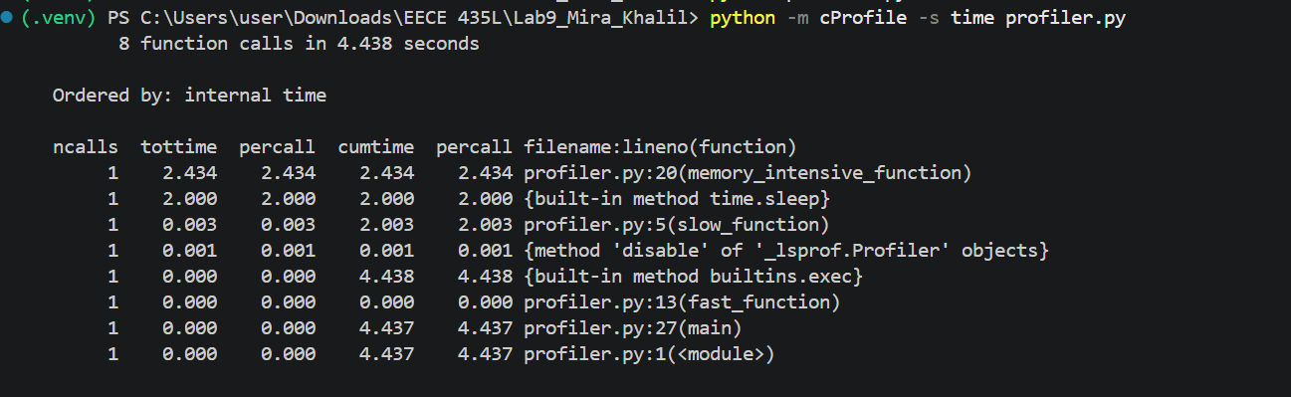

Figure 2. cProfile after optimization
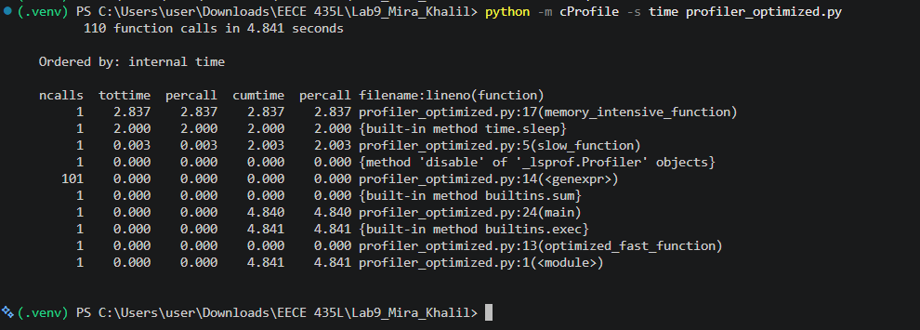

4. Line-by-line performance — line_profiler
The slow function spends about 99% of its measured time in time.sleep(2), making the intentional delay its main bottleneck. The 10-million-iteration loop dominates computational work, with the loop and addition lines accounting for nearly all its line-profiler time. The optimized fast function fell from 0.0002158 s to 0.0001216 s in the measured runs, although these very small timings are sensitive to measurement overhead.

Figure 3. line_profiler before optimization
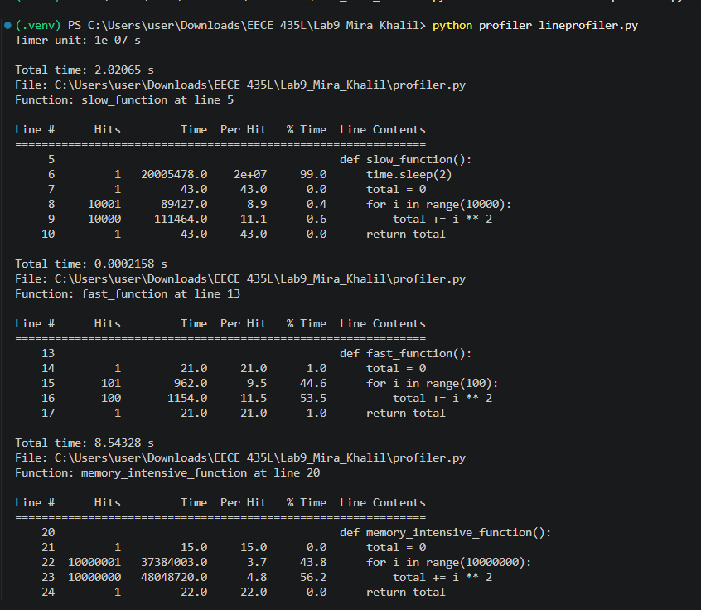

Figure 4. line_profiler after optimization
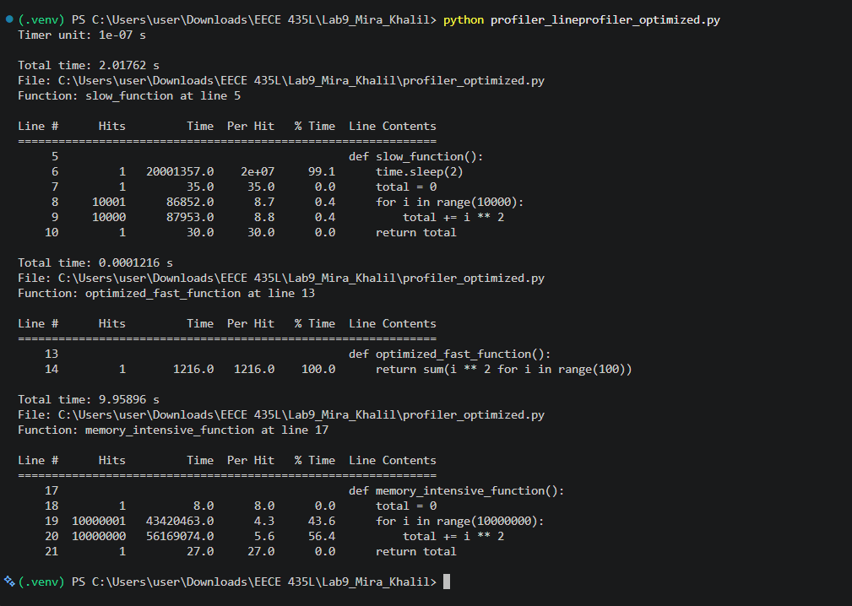

5. Memory profiling — memory_profiler
Both versions had a process memory footprint around 29–30 MiB during the line-by-line profiling runs. The fast function and its replacement showed no meaningful sustained memory increase at the reported precision. The large arithmetic loop likewise did not accumulate a large collection: it repeatedly updates a running total. Large negative “Increment” figures printed on lines executed millions of times are profiling artifacts of repeated measurements and must not be interpreted as real gigabyte-scale memory releases.

Figure 5. memory_profiler before optimization
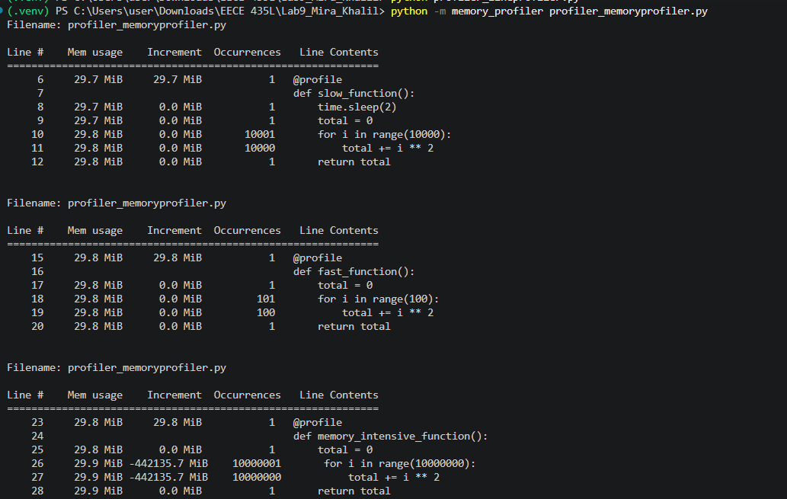

Figure 6. memory_profiler after optimization
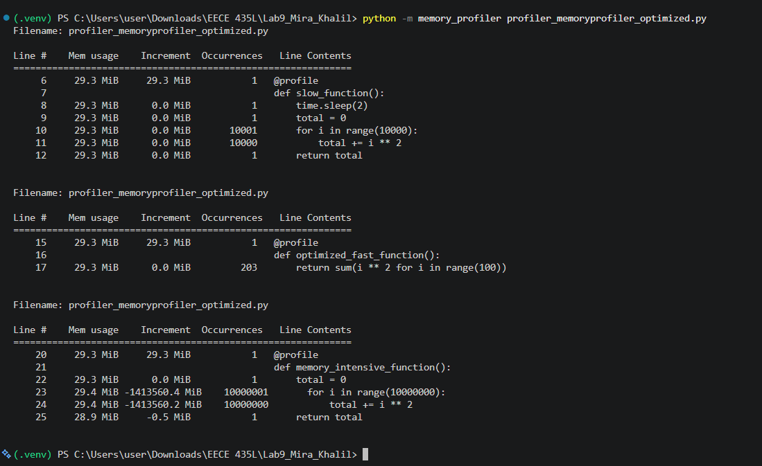

6. Unit testing
All three tests passed in both versions. The tests verify the numerical outputs of each function, check that the sleep function takes at least two seconds, and record runtime and before/after process-memory readings. A difference in memory usage between separate runs is not necessarily caused by the optimization; allocations may be reused or released by Python.

Figure 7. Unit tests before optimization
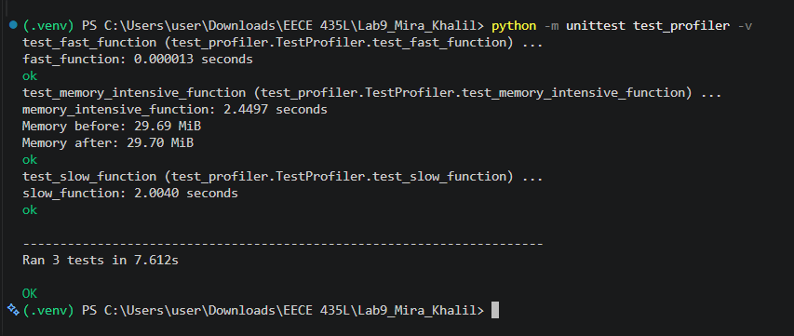

Figure 8. Unit tests after optimization
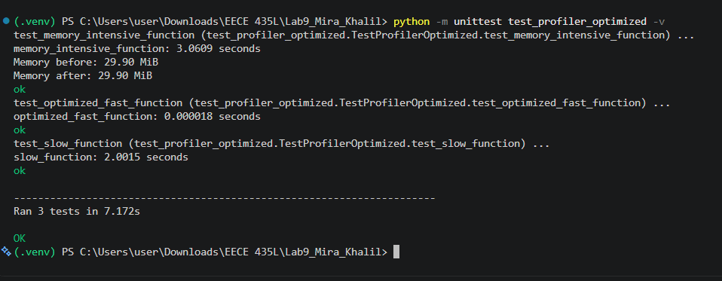

7. Coverage analysis
The original version covered 19 of 23 statements (83%), missing lines 28–30 and 34. The optimized version covered 16 of 20 statements (80%), missing lines 25–27 and 31. These missed lines correspond to the main() invocation path and the __main__ guard, which are not exercised when tests import and call the individual functions. The same four statements remain uncovered; the percentage changes because the optimized file has fewer total statements, not because previously tested function behavior was lost.

Figure 9. Terminal coverage before optimization
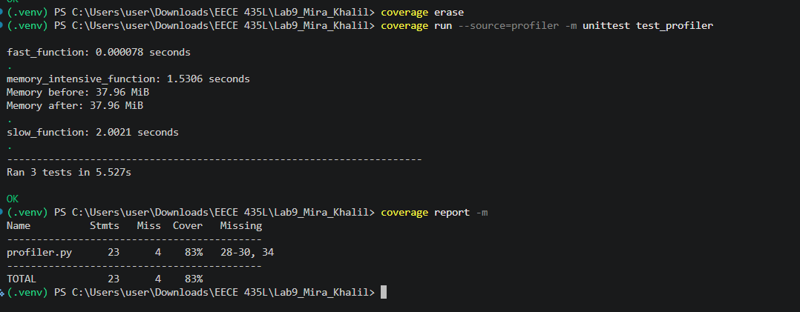

Figure 10. HTML coverage before optimization
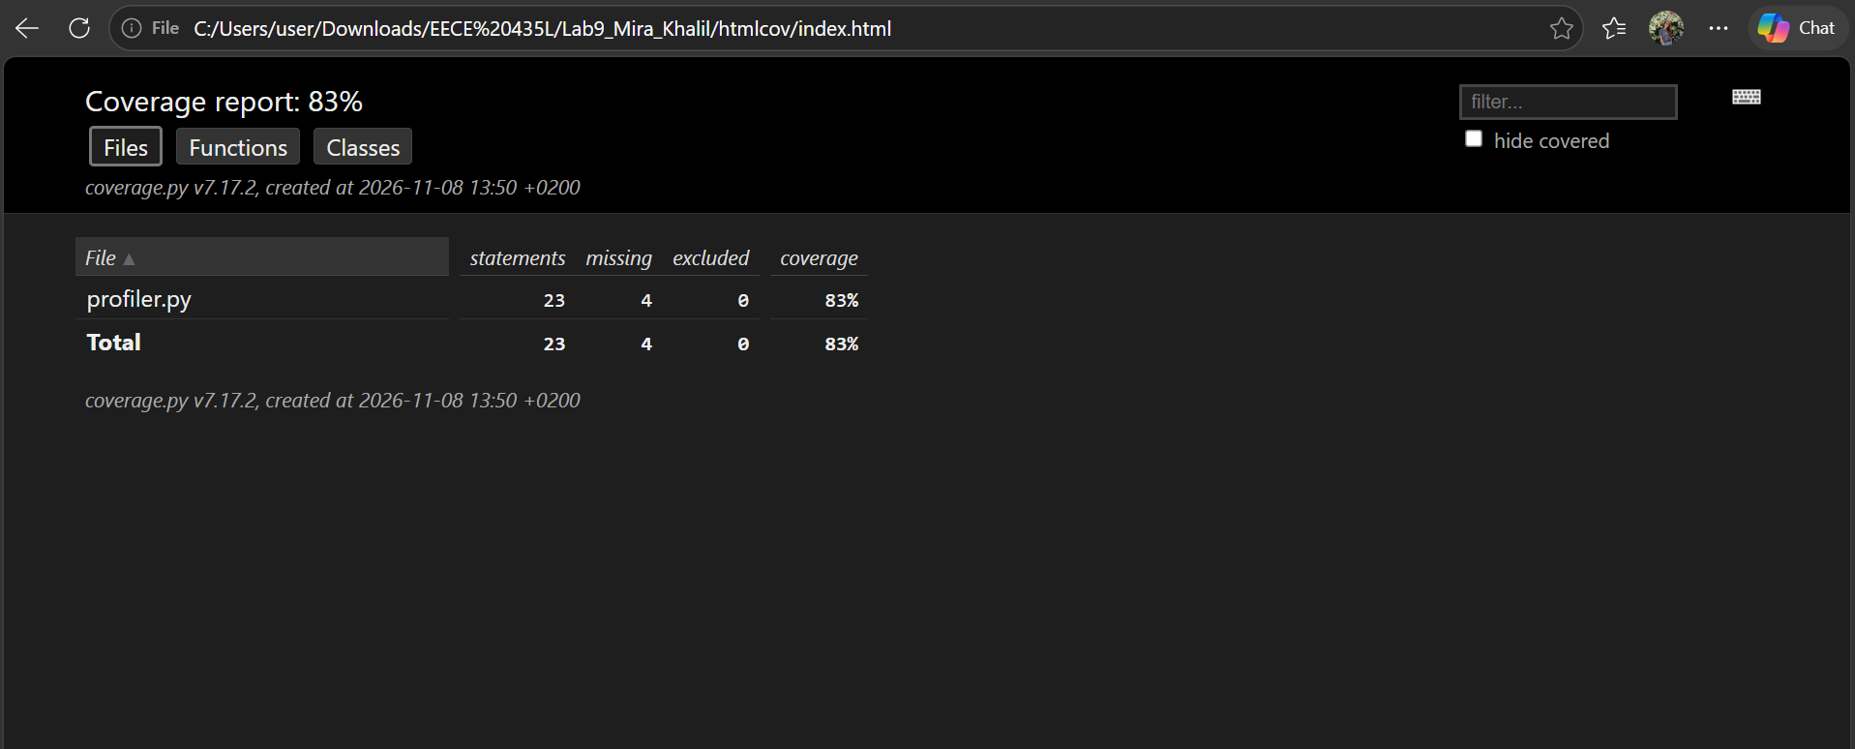

Figure 11. Terminal coverage after optimization
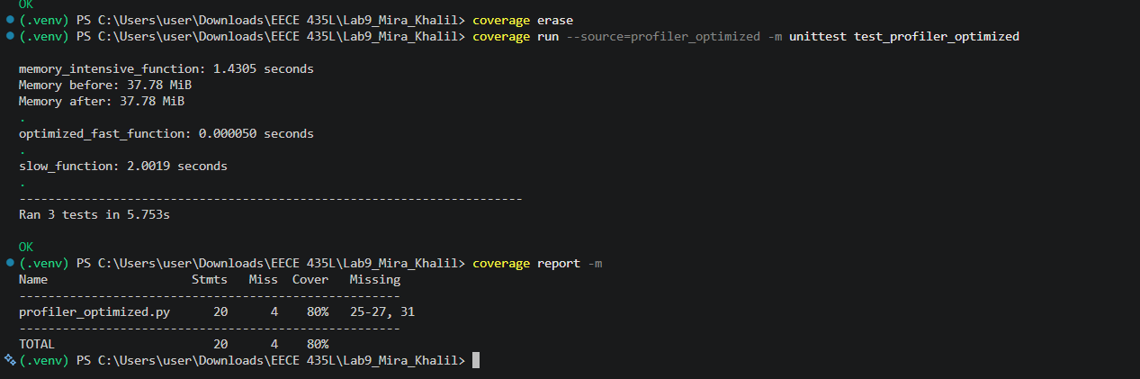

Figure 12. HTML coverage after optimization
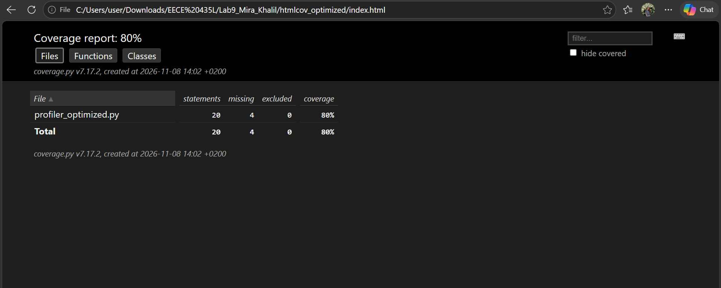

8. Conclusions
Profiling identifies the ten-million-iteration arithmetic loop and the deliberate two-second delay as the principal contributors to total runtime. The requested sum-based rewrite simplified the fast function and reduced its measured line-profiler time by about 43.7%, but this function is such a small part of the program that overall runtime did not materially improve. Both versions passed all unit tests. Coverage remained similar in absolute terms, with four statements missed in each version. Future performance work should focus on the computationally expensive loop, while recognizing that the sleep delay is intentional.
Submission note: include the original and optimized Python source files, the generated coverage HTML files/folders, and this report. The timing and memory figures are observations from the provided screenshots, not controlled repeated benchmarks.

